

**Designing cover letter in InfoPath, integrating with SharePoint**

Project Report

INFO 3250

Content Management Information Architecture (S74)

March 30, 2018

Submitted To:

Prof. Andy Law

Submitted By:

LiWen Tan

Zhexing Ma

Sandy Lee

Sum Yuk Chan

Cody Hermon

**TABLE OF CONTENTS**

**1. INTRODUCTION** 2

1.1 Background 2

**2. INTRODUCTION to InfoPath** 2

2.1 Importance to Job Hunter 2-3

**3. CV design** 4

**4. CV created by InfoPath** 5-8

4.1 Implementation and design comparison 8

**5. Screenshots**

5.1 required features of InfoPath

5.2 features to capture, store, manage and deliver CVs

**6. Conclusion**

**7. WBS and RAM**

**8. References** 5

**1. INTRODUCTION**

**1.1 Background**

Job Hunter (JH) is a company that recruits job seekers with potential jobs. Job Hunter helps its clients find a job that meets their goals. Also, every clients is required to upload a curriculum vitae (CV) summarizing their background, career goal and expectation for matching the job. Companies are able to check these applicant’s information as well.

**1.2 Purpose**

This proposal presents an effective approach for Job Hunter’s client submitting the CV. In this project, we will help Job Hunter to design and create electronic forms for its potential clients via Microsoft InfoPath. It is an efficient way to help JH with managing the data with ease. Furthermore, it saves time to organize the information and it is convenient when companies check their applicant’s information.

**2. INTRODUCTION to InfoPath**

Microsoft InfoPath is an application which will provide functionalities to design, create, and deploy electronic forms in order to capture, store, and manage data. Every form can be customized to fulfill specific requirements, such as applying various inputs, objects, and containers in conjunction with input validation rules and/or formulas to efficiently and effectively manage how data is entered.

Microsoft InfoPath has two components. The first component, InfoPath Designer, is used to design and create forms. The second component, InfoPath Filler, is used by clients to fill and submit forms. It is compatible with many other applications to deliver the form, such as Microsoft Outlook, SharePoint, etc.

**2.1 Importance to Job Hunter**

MS InfoPath offers many benefits for JH. InfoPath can be used by any JH staff, without any experience of coding, to efficiently design and create electronic forms by providing friendly graphical user interface. Secondly, InfoPath electronic forms reduce human errors, which are often found in physical forms, while entering data. Thirdly, InfoPath is integrable with many other softwares, such as SharePoint, Word, Excel, Email service, and etc.

According to Microsoft (2007), InfoPath takes care of handling “forms services”, and is fully compatible with many other programs, which are commonly used across businesses. Therefore, this makes InfoPath an essential tool for JH.

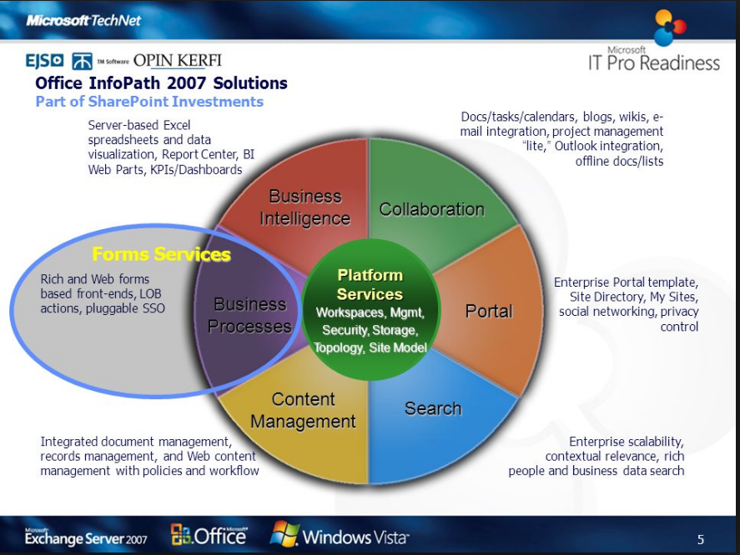

By: Microsoft, 2007

**3. CV design**

The early design of the form displays the controls, layout, and questions that will be implemented in InfoPath, as shown below.

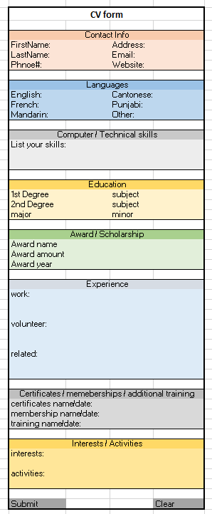

**4. CV created by InfoPath**

The actual implementation of the form is in InfoPath, as indicated below. The form sections, such as “contact information”, is created by inserting tables from the “INSERT” tab, according to Nguyen (2012).

This is the actual form designed in InfoPath, the included controls are:

* Textbox- allows user to enter text or digits
* Radio button- allows user to select only one choice among many
* Drop down list- offers choices to select
* Date picker- permits the user to pick a date
* Button- allows user to execute a command, eg. “submit”
* Picture- allows user to upload a photo
* Hyperlink- allows user to enter a URL

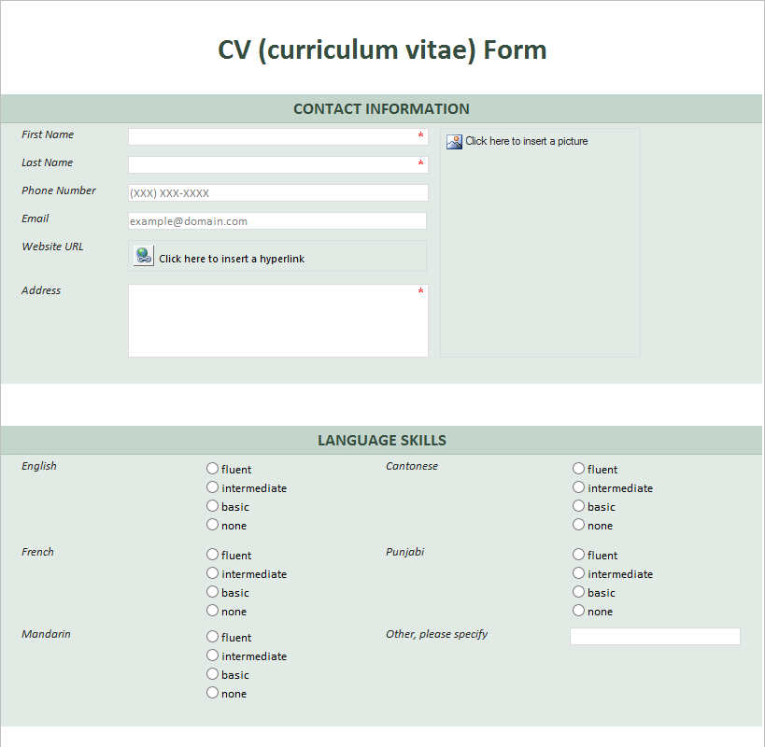

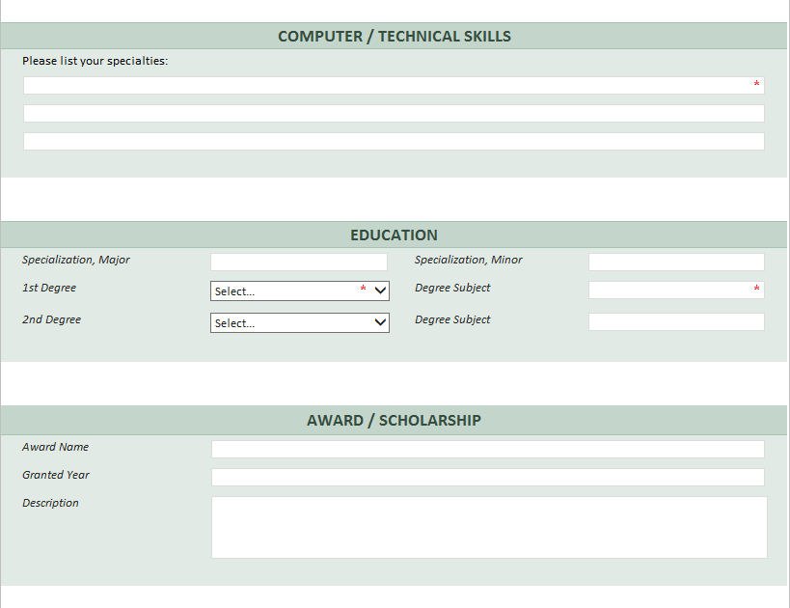

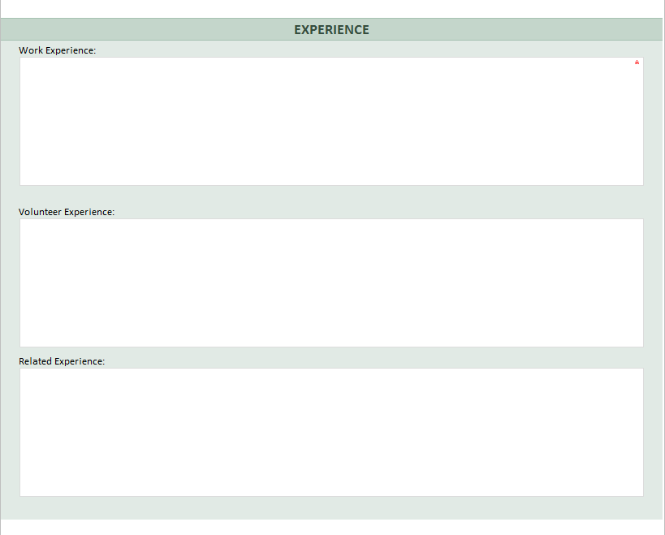

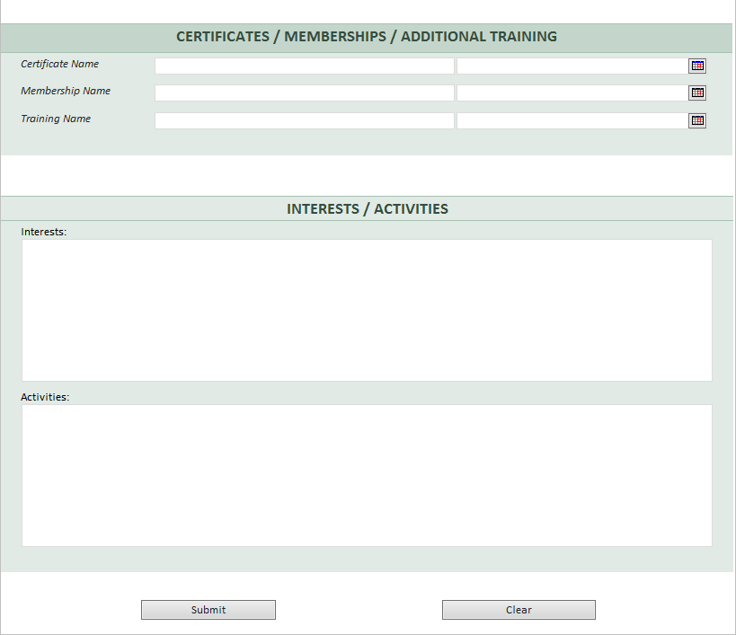

**4.1 Implementation and design comparison**

The physical design looks very similar to both the early design and InfoPath design. The logical design is much different because there is more configuration needed for the InfoPath design, such as input validation, logical expression, and formulas.

**5. Screenshots**

**• How importing is done and what inputs are available**

InfoPath can import various types of documents into a InfoPath file, with a .xsn extension. Lynda.com (2013), illustrates an example on how to import Word or Excel template, as demonstrated below:

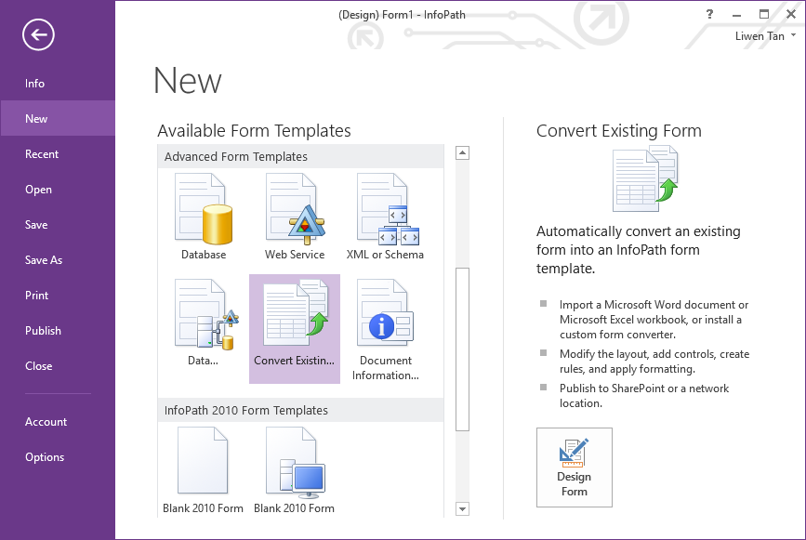

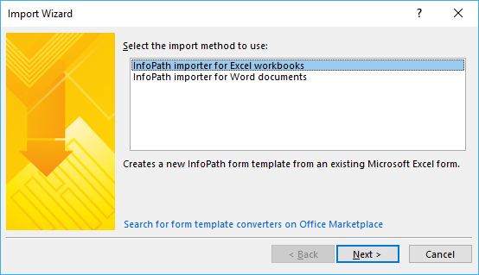

Browse the file, and click “finish”:

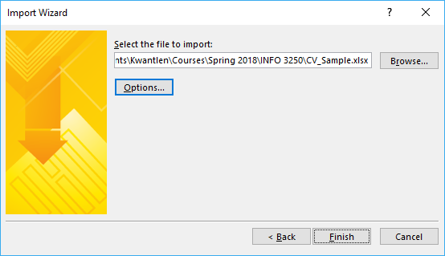

**• How a form is designed and created**

A form is designed first by drawing a rough sketch and it is created by opening InfoPath designer 2013. Click “New”, then “Blank Form”, and then “Design Form”.

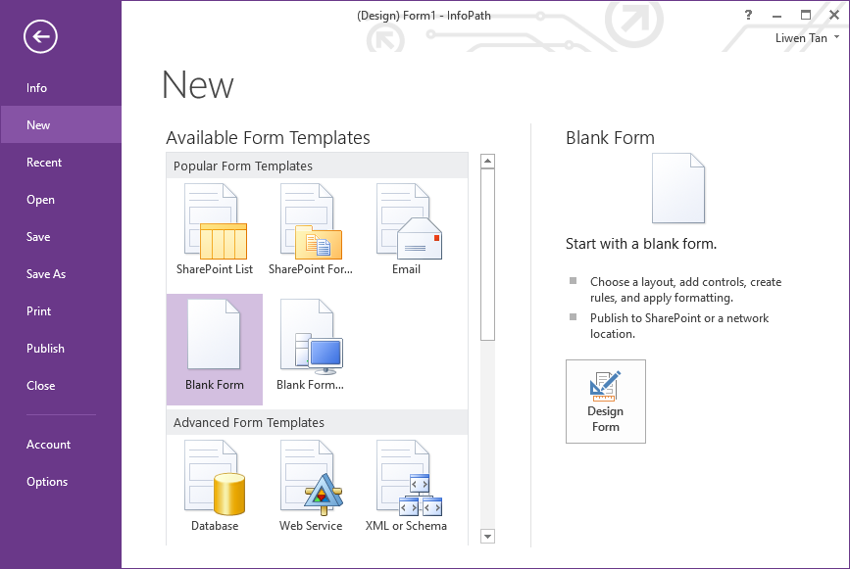

Next, use the insert tab, and insert tables from the top menu, as shown below:

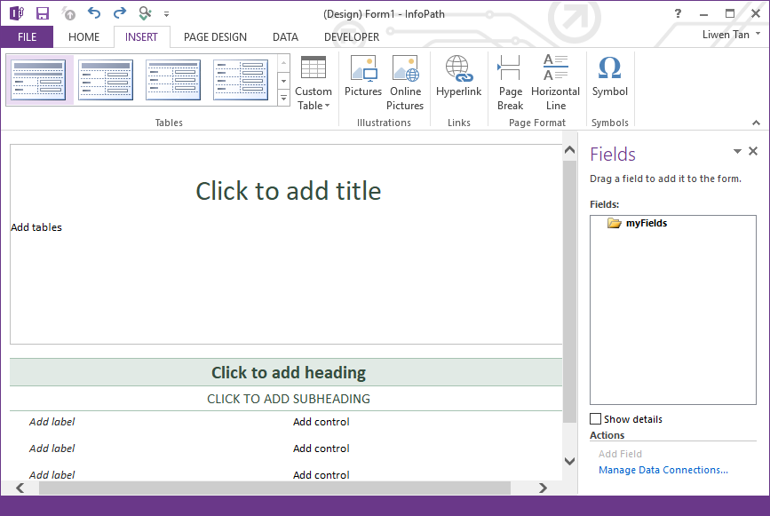

Next, a sample table is added. Fill out the form according to the CV requirement. “Add Label” is usually a question and “Add control” is the answer to the question. It could be a textbox, dropdown menu, radio buttons, etc:

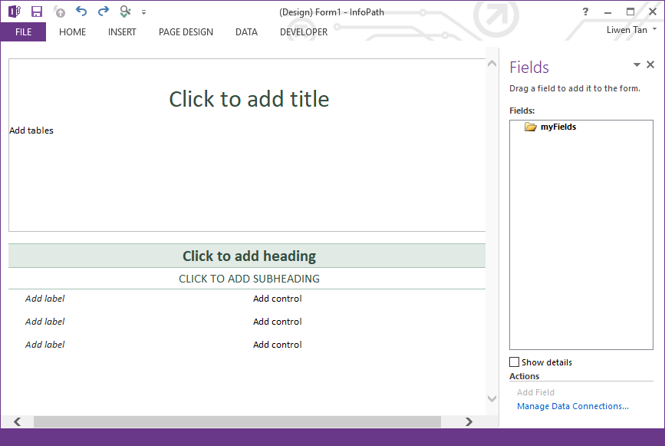

After a table is created, go to the “HOME” tab and use the “Controls” section to add control into a desired “Add control” part:

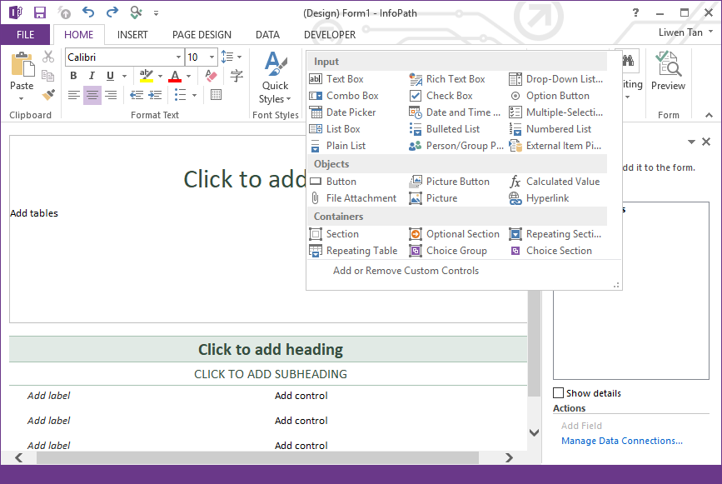

All the fields are properly named and grouped, with red asterisks for required fields, as below:

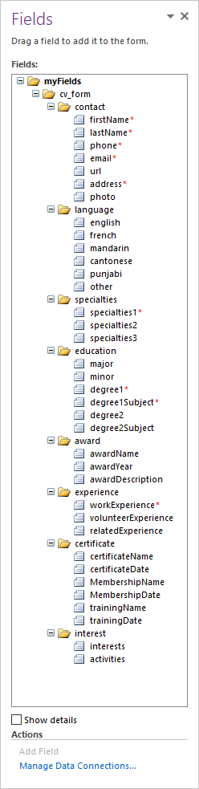

**• How rules are added to validate inputs**

Below, the screenshot shows by selecting properties of each control, such as a textbox, to ensure no empty input is allowed, by selecting “cannot be blank”:

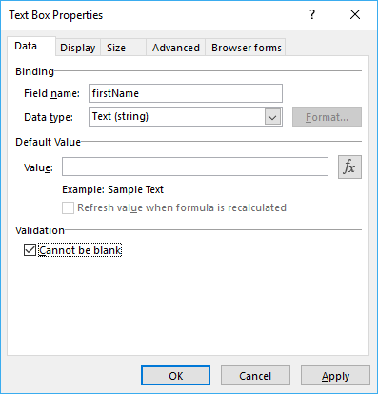

Input the telephone number into the (604)-123-1234 format. This will be automatically configured by InfoPath, once the correct conditions (BizSupportOnline, 2011) and formulas are configured, as shown by screenshots below:

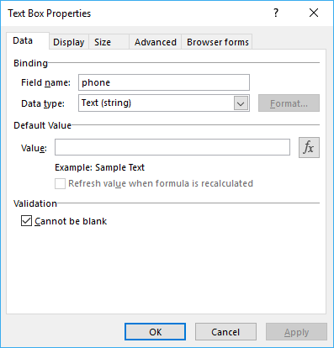

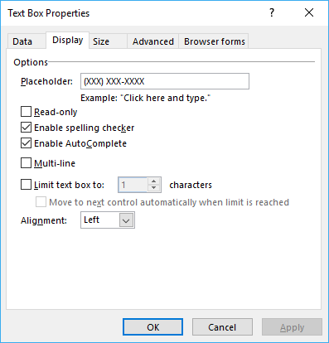

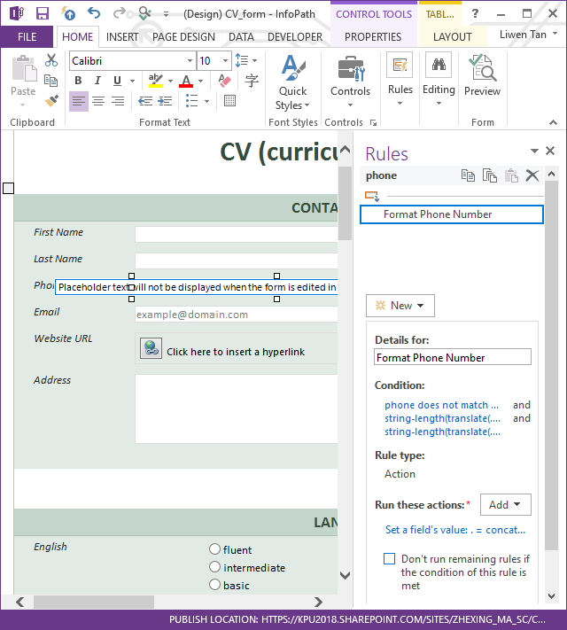

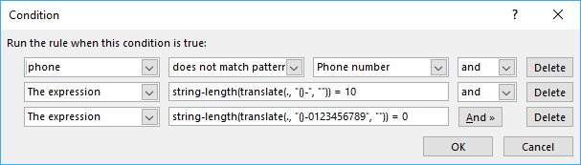

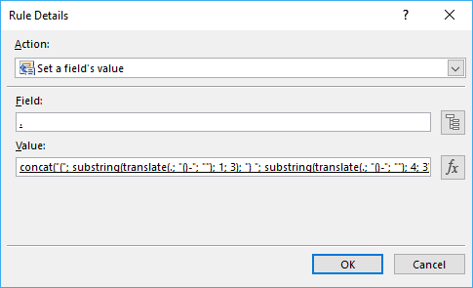

The whole formula is: concat(‘(‘, substring(translate(, ‘()-‘, ‘’),1,3), ‘)’, substring(translate(., ‘()-‘, ‘’), 4,3), ‘-‘, substring(translate(., ‘()-‘, ‘’),7,4)), according to InfoPathDev.com (2008).

Another case is that the user forgets to enter all the required fields, as indicated by an asterisk, and tries to submit the form. InfoPath shows an error message as below:

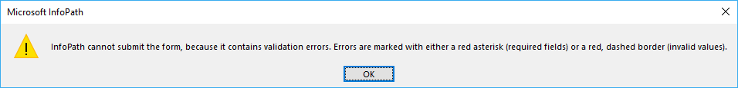

**• How output is done and what output options are available**

Please refer to section 5.2 demonstration on how InfoPath sends the form as an email attachment. It is also part of delivering data.

**• Other options**

InfoPath allows users to upload a picture, with the “Picture” feature in the “Controls” group.

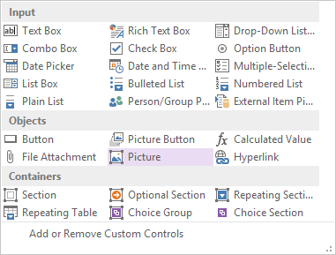

Now, open the form from InfoPath Filler. Users can upload a picture, as shown below:

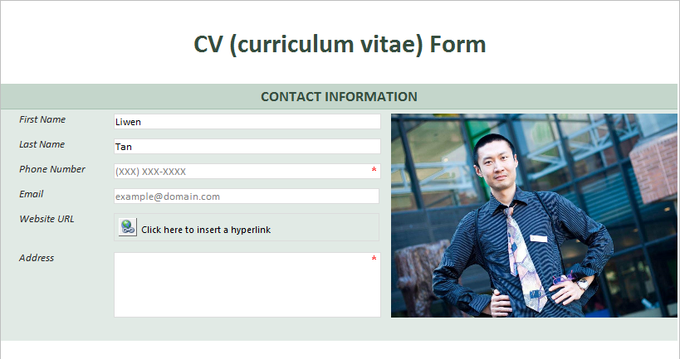

Another feature called “Hyperlink” allows user to insert an URL into the CV form. It is located at “Controls” group, under “HOME” tab, as below:

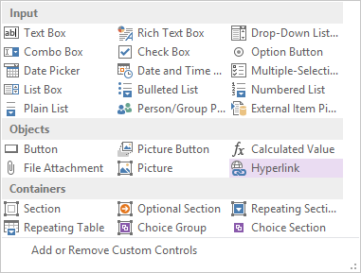

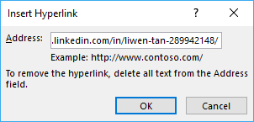

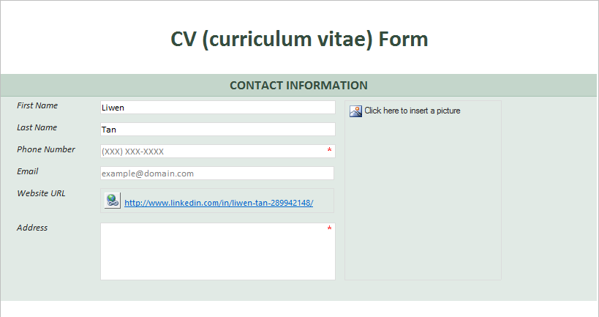

Now, if user clicks on “LinkedIn”, it takes user to the website that is configured from above.

**5.1 required features of InfoPath**

The features must be able to achieve capturing, storing, managing, and delivering data as required, and are fully explored in section 5.2.

**5.2 features to capture, store, manage and deliver CVs**

**5.2.1 Submit by E-mail**

A user fills out the form from InfoPath Filler 2013, then clicks on the submit button, and InfoPath emails the form to a pre-configured email address, as demonstrated by the below screenshots.

Go to “submit” button properties:

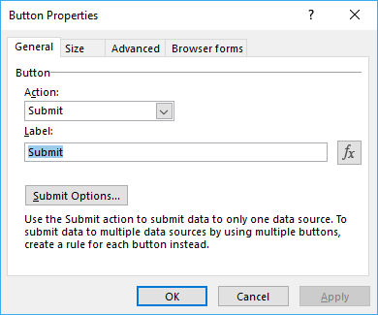

Then go to “submit options”, and click “OK”:

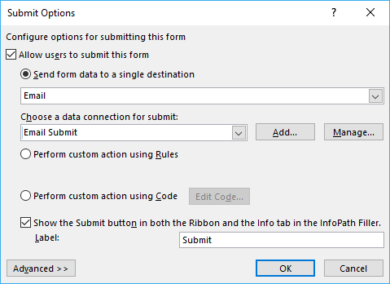

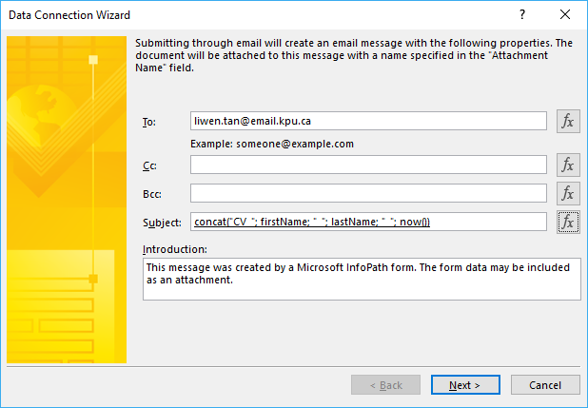

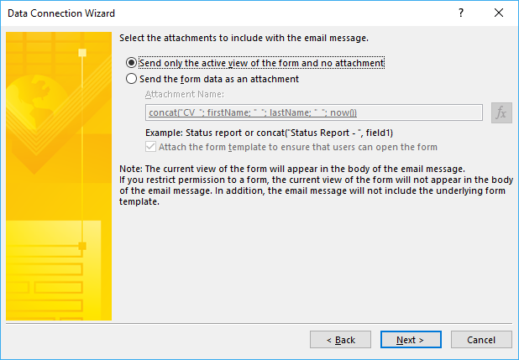

Next, click “finish”:

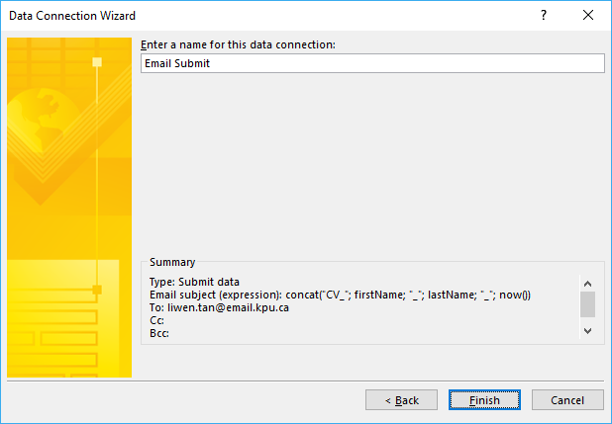

Set up Outlook email connection, as below:

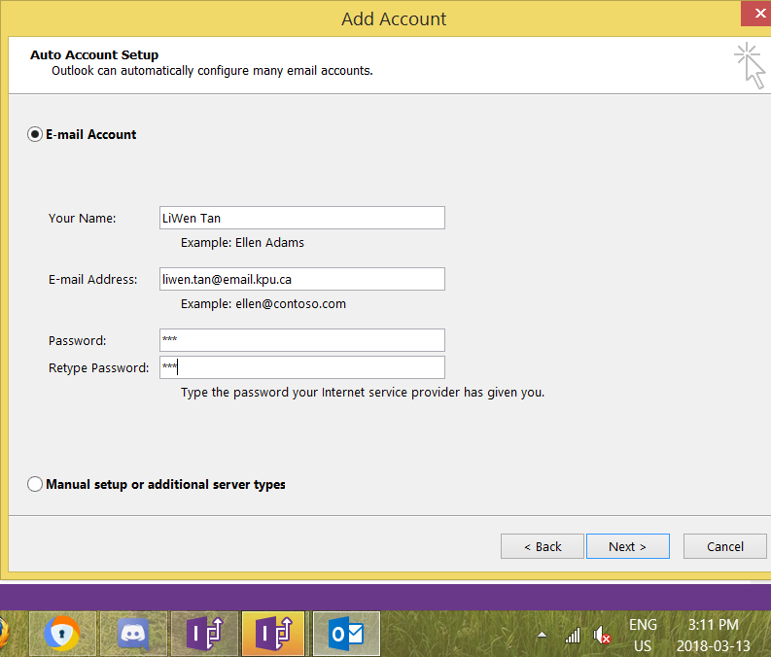

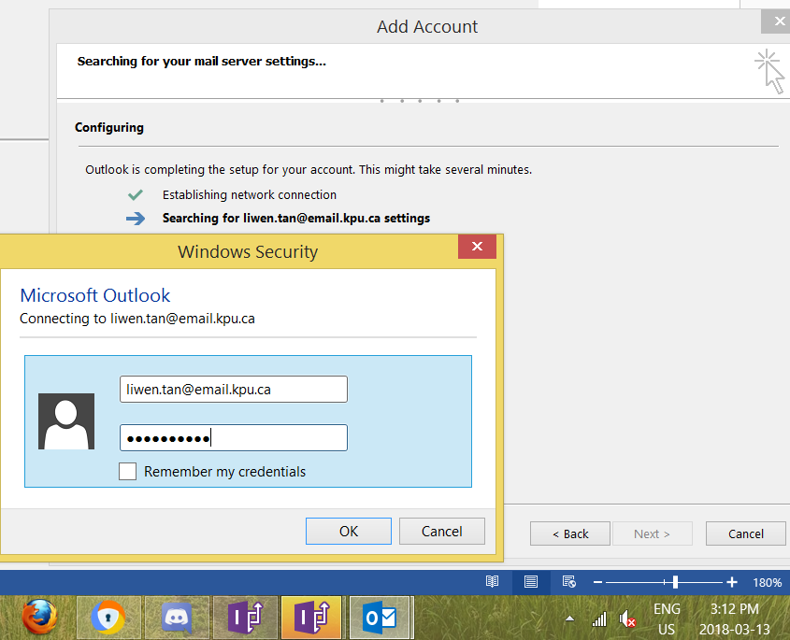

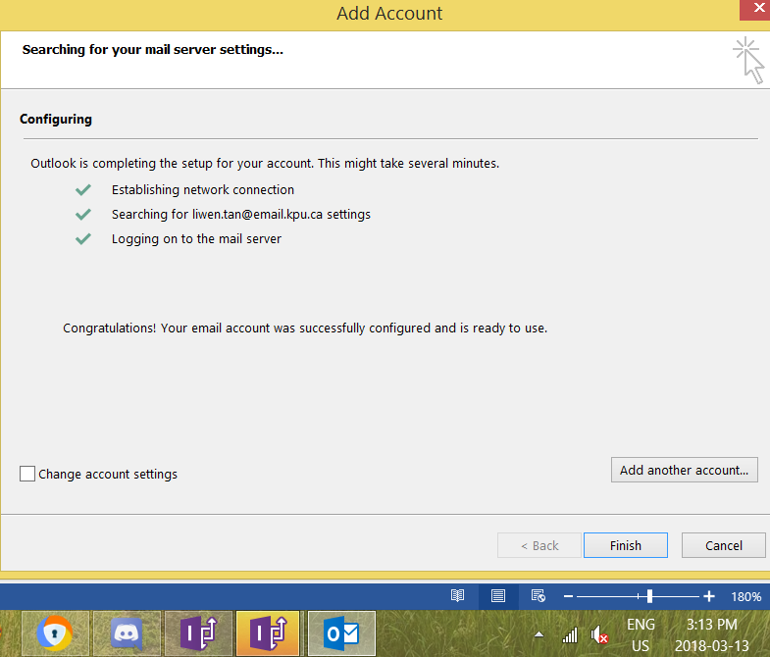

Open the .xsn InfoPath file from InfoPath Filler, then fill the form, and click “submit” button to send the form to email address, as set up from above:

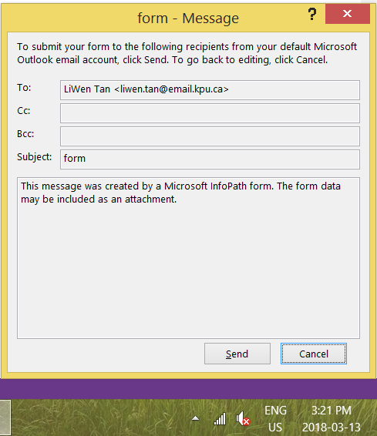

Then, the InfoPath form was send to the email address as below:

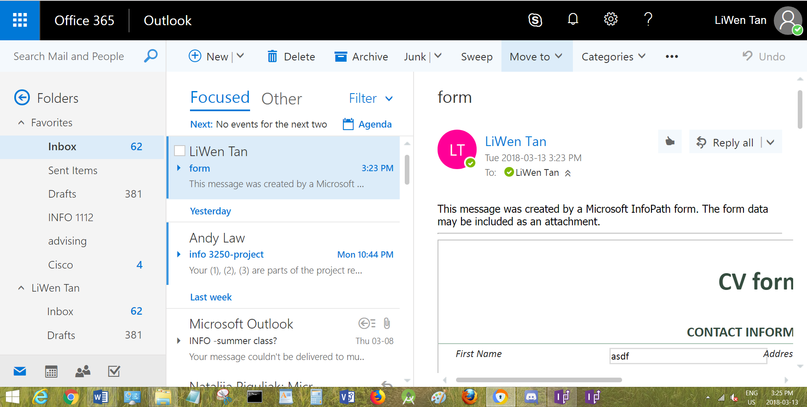

**5.2.2 Submit to Sharepoint document library**

**5.2.2.1 Create a document library**

To submit CV forms to a Sharepoint document library, a document library needs to be created. To do this, publish the form to “Sharepoint Server”.

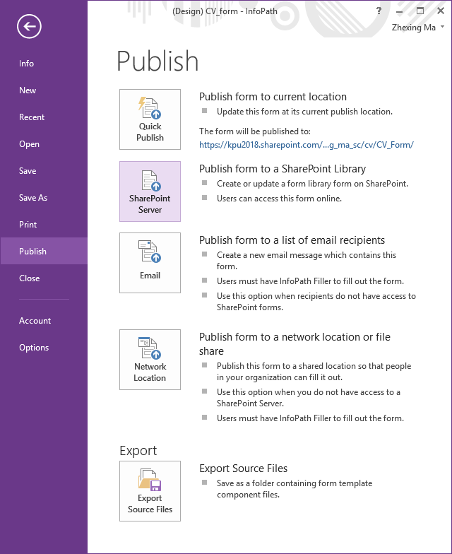

The new “CV_Form” document library is to be created in the subsite “cv”.

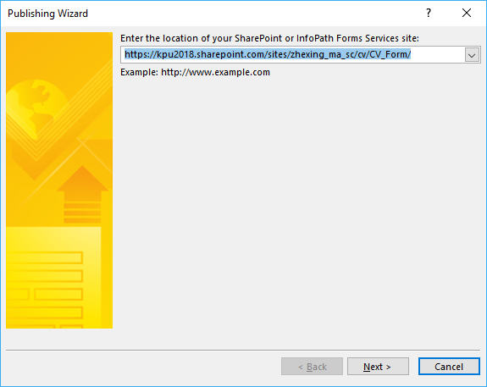

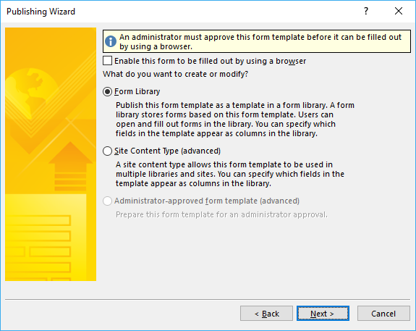

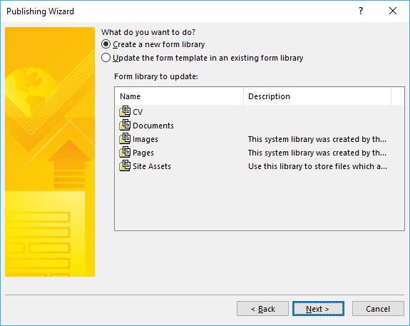

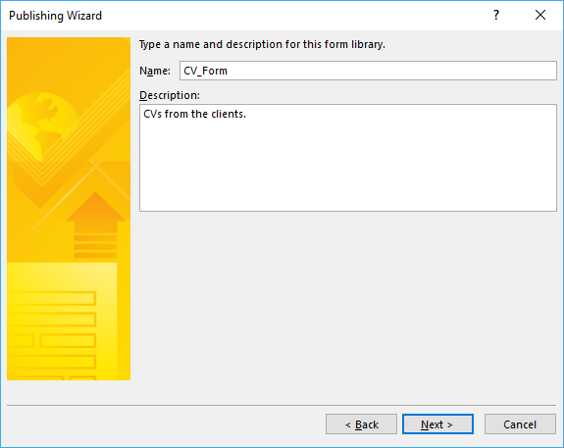

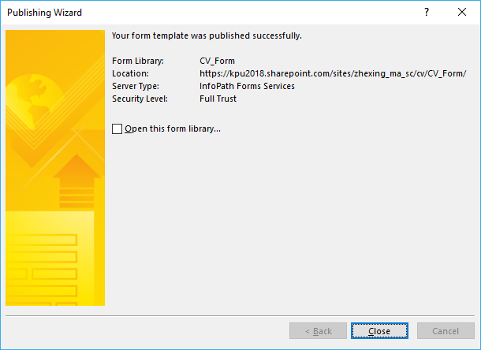

**5.2.2.2 Configure the “Submit” button**

Select “SharePoint document library” as the destination.

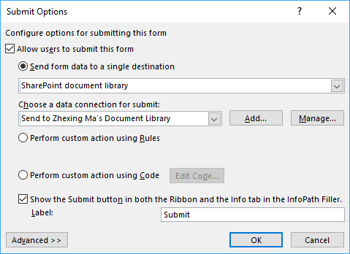

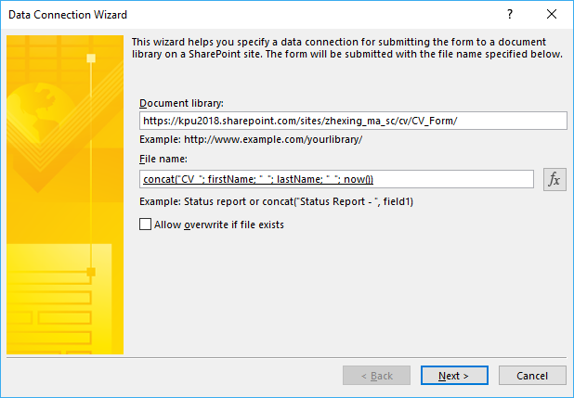

The file name is in the format “concat("CV_"; firstName; "_"; lastName; "_"; now())”. An example of file name is “CV_Zhexing_Ma_2018-03-24T15_34_35.xml”. The submitted time is added at the end of the file name in order to avoid file name conflicts in the document library.

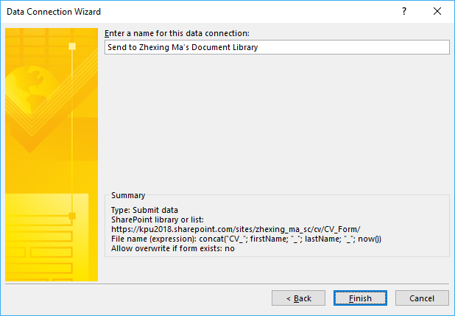

**5.2.2.3 Configure permission settings on the server**

The owner of the document library has full control while the clients can submit and view their own documents but cannot view others’ documents. The clients cannot edit or delete any document on the server either.

To implement, the new permission level needs to be set up at the site collection level. In the screenshot below, the “Add Only” permission level is created with “Add Items” and “View Items” permissions granted.

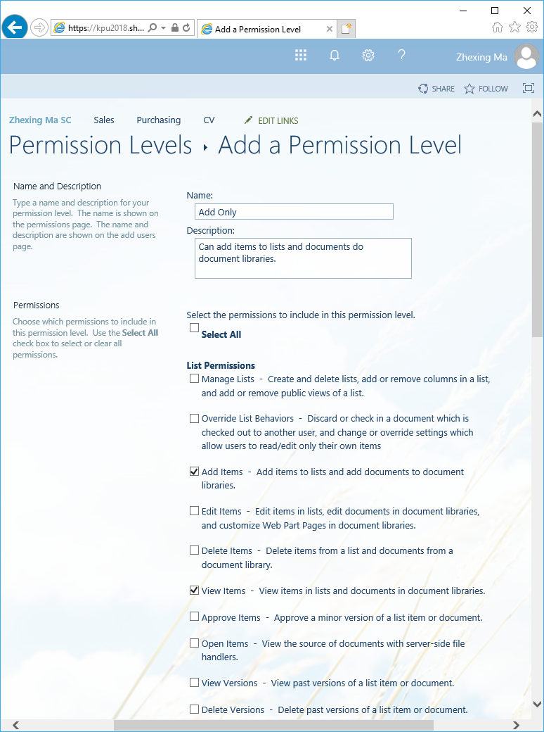

It is convenient to manage the clients by putting all the clients in a group. The “CV_Clients” group is created under the subsite “cv”.

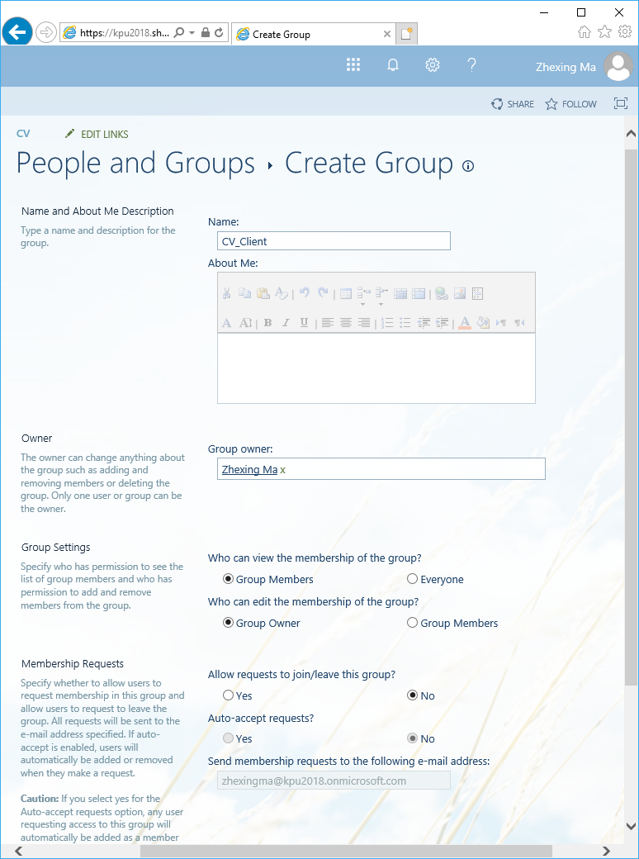

In the permission settings of “CV_Form” document library, inheriting permissions is stopped, the group “CV_Client” is created and other users and groups are removed.

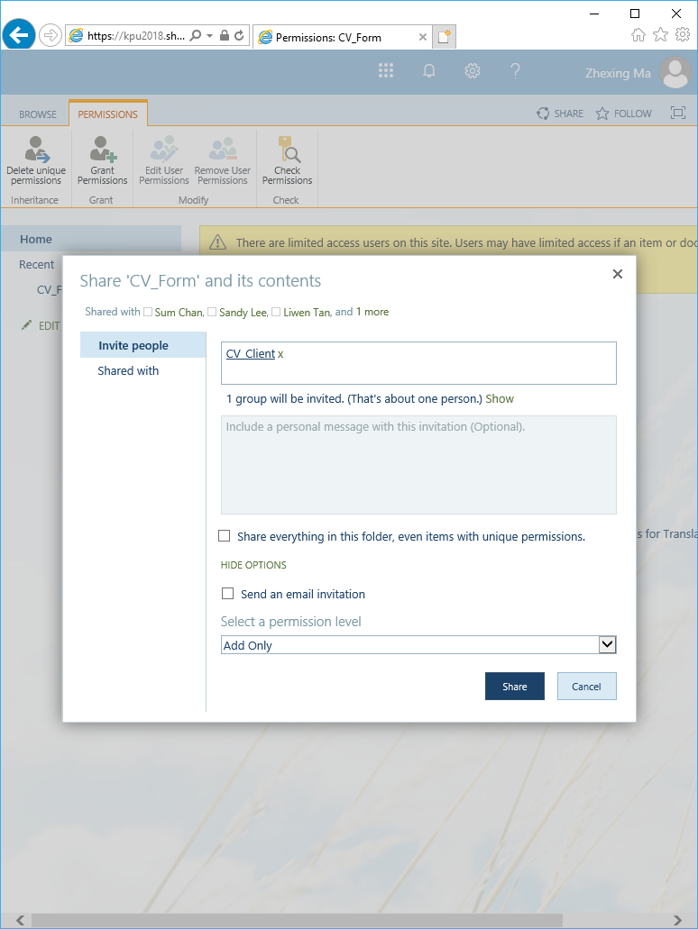

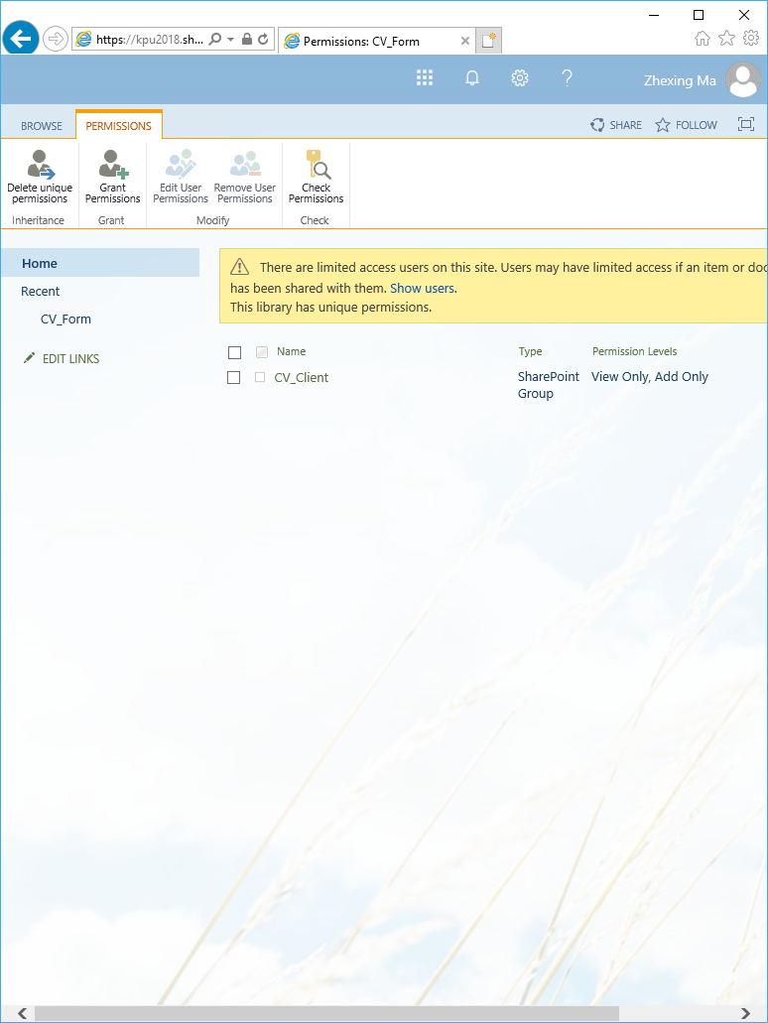

The group “CV_Client” also needs to be granted the “View Only” permission for successful submissions.

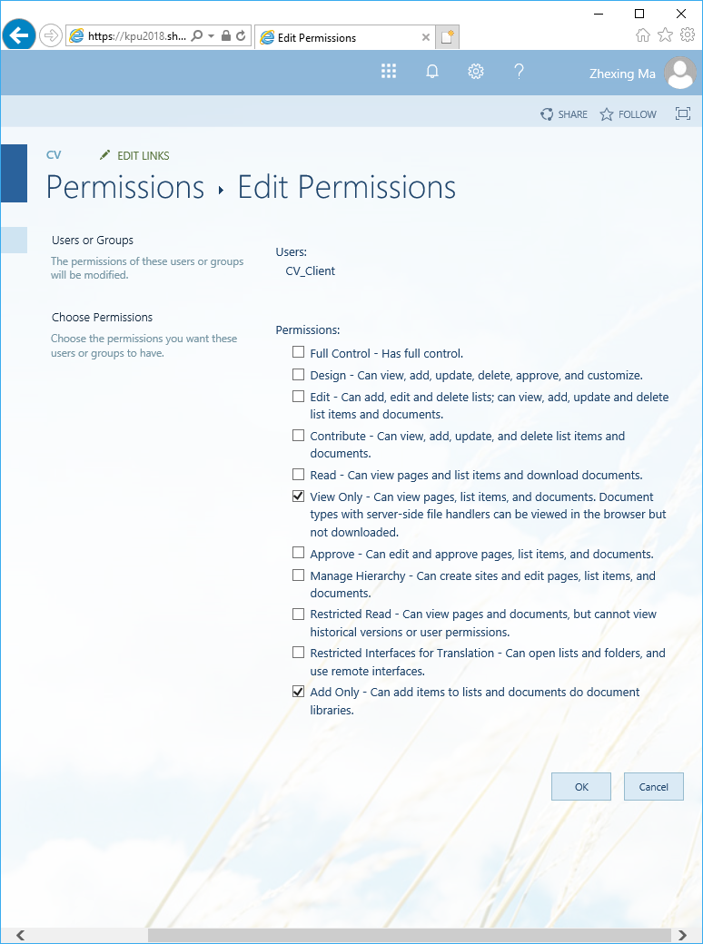

**5.2.2.4 Add clients to the group**

All the clients first need to be added to the domain, then to the “CV_Client” group.

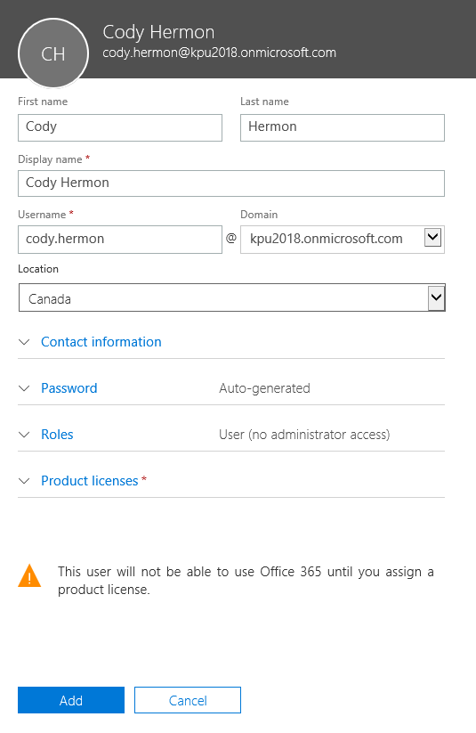

The below screenshot shows the same process of adding another three more users:

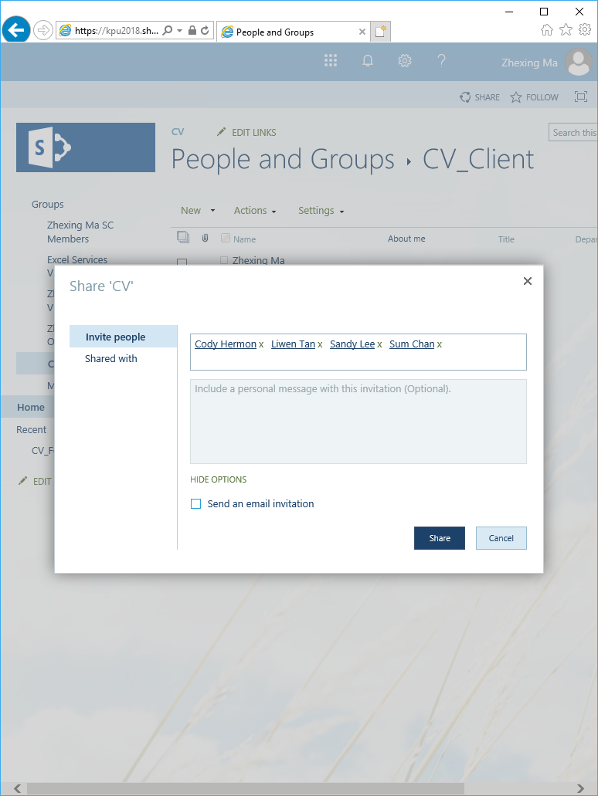

**5.2.2.5 Clients submit form**

The message boxes are configured in the advanced submit options.

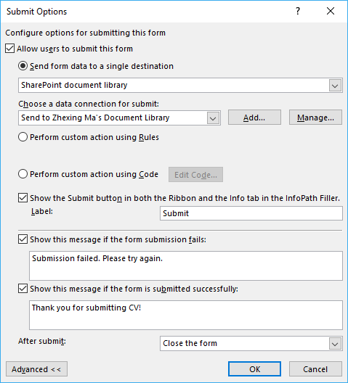

After the “Submit” button is clicked, if the form is submitted successfully, a message is displayed.

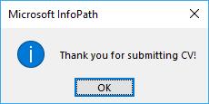

In case of error, an error message with details is displayed.

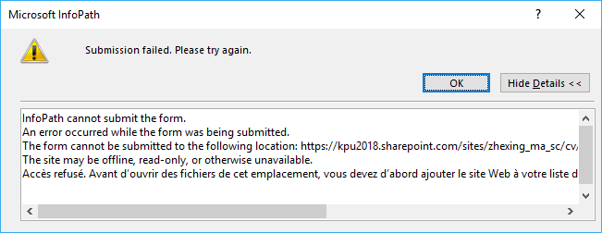

The following screenshot shows how documents are presented in the document library.

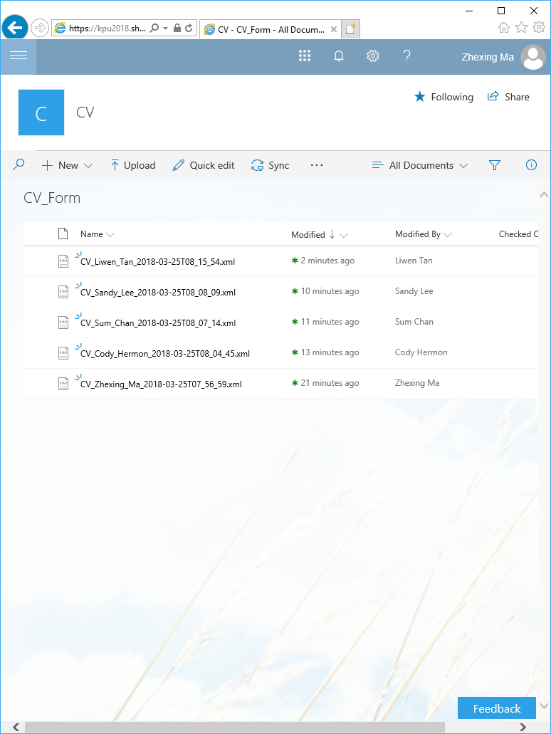

**5.2.2.6 Document library security feature**

As the document library owner, Zhexing Ma is able to view, edit and delete all the documents.

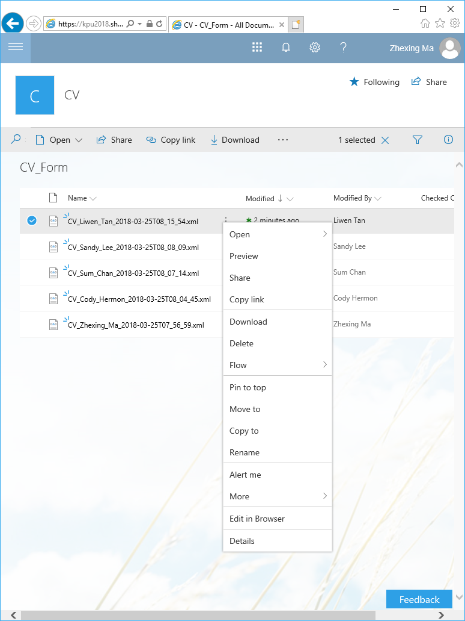

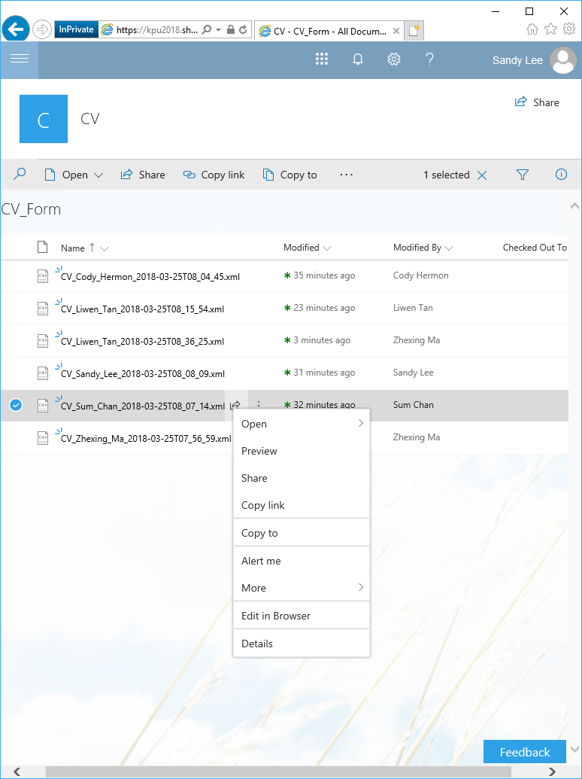

As a client, Sandy Lee is able to submit form, but is unable to view, edit or delete any document including Sandy’s own files. Although “Open”, “Preview” and “Edit” options appear in the menu, an “Access Denied” message appears after these options are selected.

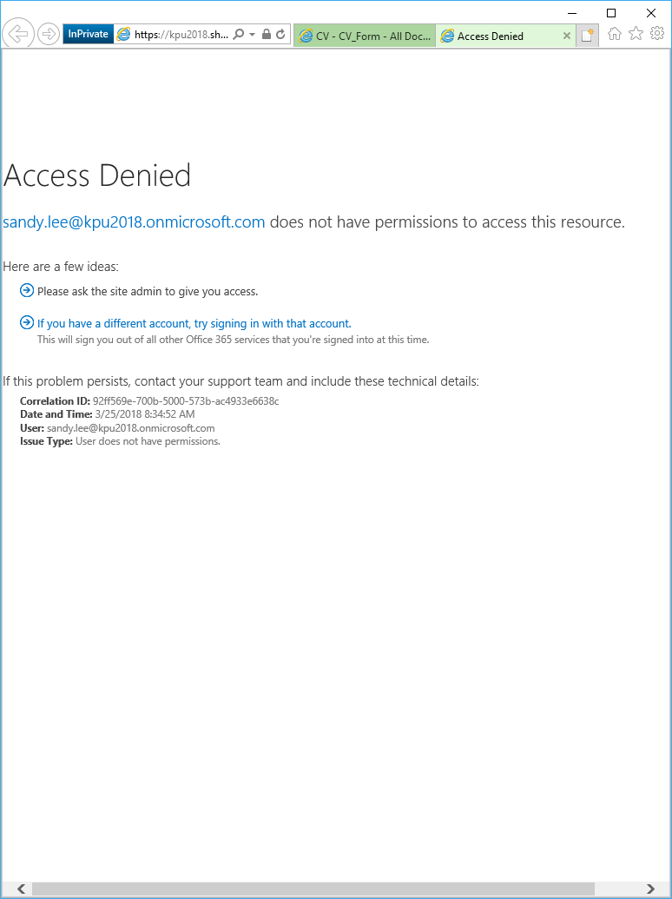

**Clear button:**

A user types information into the field like below:

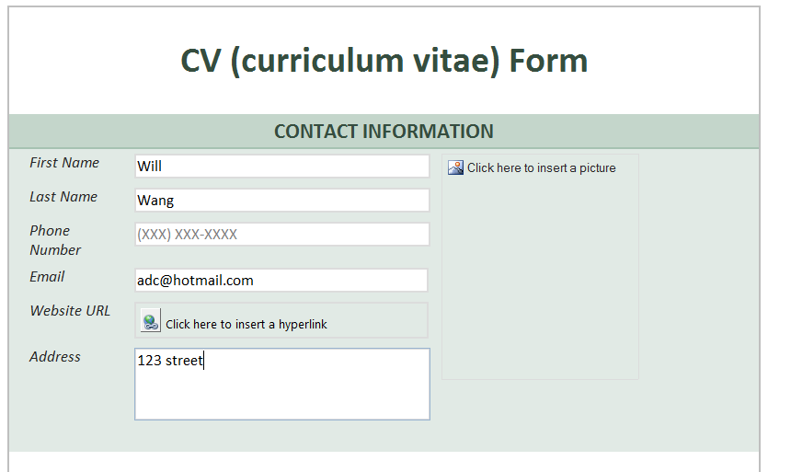

Then clicks on the “clear” button, a message shows to user to confirm, as below:

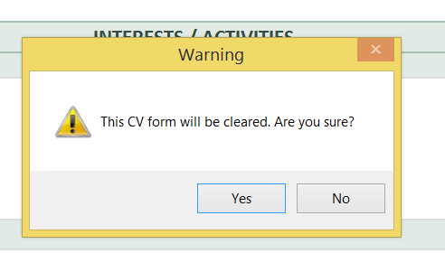

When the user clicks “yes”, the fields are cleared as below:

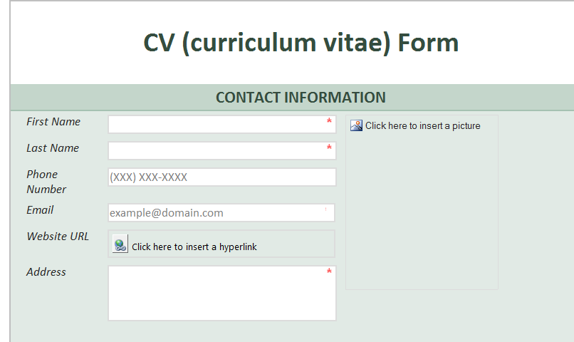

Since InfoPath does not have the built-in function to reset form, this function is implemented through coding. The following is the source code:

using Microsoft.Office.InfoPath;

using System;

using System.Xml;

using System.Xml.XPath;

using System.Windows.Forms;

namespace CV_form_clear

{

public partial class FormCode

{

private object initialData

{

get

{

return FormState["initialData"];

}

set

{

FormState["initialData"] = value;

}

}

public void InternalStartup()

{

((ButtonEvent)EventManager.ControlEvents["CTRL50_5"]).

Clicked +=

new ClickedEventHandler(CTRL50_5_Clicked);

EventManager.FormEvents.Loading +=

new LoadingEventHandler(FormEvents_Loading);

}

public void FormEvents_Loading(object sender,

LoadingEventArgs e)

{

// When the form is loaded, save the initial data

// of the form into the property "initialData".

XPathNavigator root =

MainDataSource.CreateNavigator();

initialData = root.SelectSingleNode("//my:cv_form",

NamespaceManager).OuterXml;

}

public void CTRL50_5_Clicked(object sender,

ClickedEventArgs e)

{

// When the "clear" button is clicked, a confirmation

// message box is shown with default button "no"

// focused.

DialogResult confirmClear = MessageBox.

Show(

"This CV form will be cleared. Are you sure?",

"Warning", MessageBoxButtons.YesNo,

MessageBoxIcon.Exclamation,

MessageBoxDefaultButton.Button2);

if (confirmClear == DialogResult.Yes)

{

// Replace the form with the initial data.

XPathNavigator root =

MainDataSource.CreateNavigator();

XPathNavigator container =

root.SelectSingleNode("//my:cv_form",

NamespaceManager);

if (initialData != null)

{

container.ReplaceSelf((string)initialData);

}

}

}

}

}

**6. Conclusion**

It is recommended that JH adopts InfoPath to design, create electronic forms for its potential clients. Anyone without knowledge of programming can easily create forms using InfoPath’s graphical interface, by clicking and dragging controls and tables. Additionally, InfoPath provides seamless integration with many other applications, like Sharepoint, Outlook, Excel, Word, etc. Furthermore, InfoPath removes the need for manual data entry into database, error checking, deciphering illegible handwriting, by automating all these processes. Lastly, InfoPath accomplishes capturing, storing, managing and delivering of information throughout the organization.

**7. WBS and RAM**

WBS (Work Breakdown Structure):

Job Hunter's CV InfoPath WBS

1

Initiation

1.1

Evaluation & Recommendations

1.1.1

Develop Project Charter

1.1.2

Deliverable: Submit Project Charter

1.1.3

Project Sponsor Reviews Project Charter

1.1.4

Project Charter Signed/Approved

1.1.5

Planning

1.2

Create Preliminary Scope Statement

1.2.1

Determine Project Team

1.2.2

Project Team Kickoff Meeting

1.2.3

Develop Project Plan

1.2.4

Submit Project Plan

1.2.5

Milestone: Project Plan Approved

1.2.6

Execution

1.3

Project Kickoff Meeting

1.3.1

Verify & Validate User Requirements

1.3.2

Design System

1.3.3

Procure Hardware/Software

1.3.4

Install Development System

1.3.5

Testing Phase

1.3.6

Install Live System

1.3.7

User Training

1.3.8

Go Live

1.3.9

Control

1.4

Project Management

1.4.1

Project Status Meetings

1.4.2

Risk Management

1.4.3

Update Project Management Plan

1.4.4

Closeout

1.5

Audit Procurement

1.5.1

Document Lessons Learned

1.5.2

Update Files/ Records

1.5.3

Gain Formal Acceptance

1.5.4

Archive Files/ Documents

1.5.5

RAM (Responsibility Assignment Matrix):

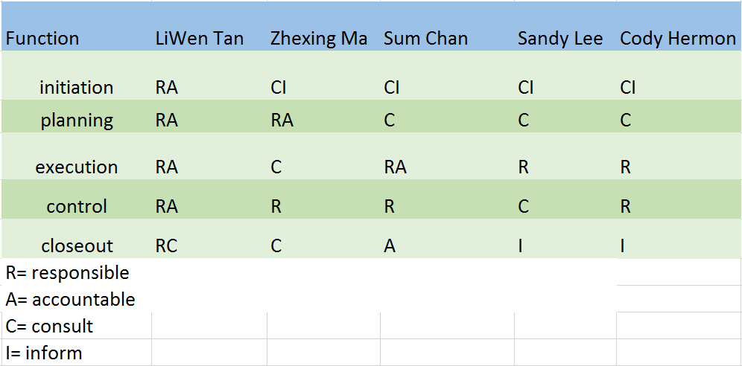

**8. References**

Microsoft, <http://slideplayer.com/slide/8857565/>, 2007

McGill, *How to write a CV*, <https://www.mcgill.ca/caps/files/caps/guide_cv.pdf>, 2017

Nguyen, Minh Tri. *Create and Design Form in MS Infopath 2010 part 1.* <https://www.youtube.com/watch?v=_NKwzXHk0ew>, 2012

Lynda.com, *InfoPath tutorial: Importing Word and Excel forms* <https://www.youtube.com/watch?v=JynJYB7PZrA&t=161s>, 2013

BizSupportOnline*.InfoPath 2010 formatting rule condition*,<https://www.youtube.com/watch?v=fcjWnFi2r3U&t=0s&index=10&list=PL0CBC55FCF6A495E9>, 2011

BizSupportOnline. *Trick: Clear or reset fields in InfoPath using only 3 lines of code*. <http://www.bizsupportonline.net/blog/2009/clear-reset-fields-infopath-3-lines-code.htm>

InfoPathDev.com, <http://www.infopathdev.com/forums/p/9304/32948.aspx>, 2008